**Document Contents:**

* **Structured Pyramid Analysis Plan for Istanbul Airbnb Price Prediction**
* **Explanation of SPAP**
* **Hypothesis**
* **Key Performance Indicators (KPIs)**

**Structured Pyramid Analysis Plan** for Istanbul Airbnb Price Prediction:

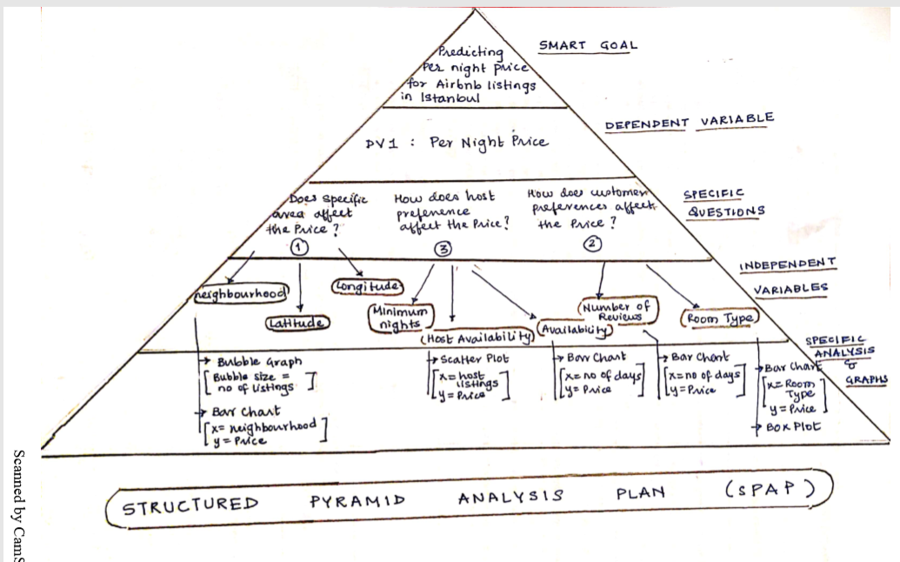

**Explanation of SPAP:**

**SMART GOAL:**

Predicting the per night price for Airbnb listing in Istanbul, given various factors like neighborhood, room type, number of reviews etc.

**DEPENDENT VARIABLE:**

DV1: Per night Price for the Airbnb listed property in Istanbul

**SPECIFIC QUESTIONS**:

1. **Does specific area affect price?**

Based on below factors:

* Neighborhood
* Latitude
* Longitude

1. **How does host preferences affect the price?**

Based on below factors:

* Minimum nights
* Availability

1. **How does customer preferences affect the price?**

Based on below factors:

* Number of reviews
* Room type

**Rearranged above mentioned Specific Questions (Rank ordering questions) based on the relative strength of their impact:**

1. **How does the area affect price?**

* Neighbourhood
* Latitude
* Longitude

1. **How does customer preferences affect the price?**

* Number of reviews
* Room type

1. **How does host preferences affect the price?**

* Minimum nights
* Availability

**INDEPENDENT VARIABLE**:

Below mentioned are the Specific Questions and Independent variables associated with them.

1. What neighborhood in Istanbul are popular?
2. How are neighborhood and price related to each other?

* **Neighbourhood**
* **latitude**
* **longitude**
* **Calculated_host_listings_count**

1. How does the room type affect the price?

* **Room_type, Price**

1. Does minimum number of nights have any impact on pricing?

* **Minimum_nights, Price**

1. Does price increase depending upon the number of reviews?

* **Number_of_reviews**

1. Does host listing count impact price?

* **Calculated_host_listings_count**

1. Does price increase with increase in availability?

* **Availability_365**

1. Which host is contributing most to the Airbnb revenue?

* **Host_name**

**SPECIFIC GRAPHS AND ANALYSIS:**

1. What neighborhood in Istanbul are popular?

* Bubble graph –> size of buble=number of listings in the particular area

1. How are neighborhood and price related to each other?

* Bar chart ( x-axis =neighbrhood, y-axis=price)

1. How does the room type affect the price?

* Bar Chart (x-axis = Room type, y-axis=Price) / Box Plot

1. Does price increase depending upon the number of reviews?

* Bar chart (x-axis = no of reviews, y-axis = price)

1. Does host listing count impact price?

* Scatter Plot,( x-axis = host listing count, y-axis=price)

1. Does price increase with increase in availability?

* Bar Chart (x-axis = no. of days available y-axis=price)

**HYPOTHESIS:**

**Main Question:** Predicting the prices per night of Airbnb rentals in Istanbul given various factors like neighborhood, room type, number of reviews etc.

**Hypothesis for the main question :** For high impact neighborhood, airbnb price prediction would lie in the range of 100 -200 dollars.

**Hypothesis for the sub-questions that we are going to address:**

1. What neighborhood in Istanbul are popular?

* Fatih has maximum Airbnb listings in Istanbul.

1. How are neighborhood and price related to each other?

* Fatih is the neighborhood having the higher price.
* Neighbourhood is the most significant parameter affecting the Price.

1. How does the room type affect the price?

* ‘Entire Room’ is the most expensive one.

1. Does minimum number of nights have any impact on pricing?

* The least minimum number of nights seems to have higher prices
* ‘Minimun number of nights’ value does not affect the Price.

1. Does price increase depending upon the number of reviews?

* Higher the reviews, affordable the prices

1. Does host listing count impact price?

* Number of listings does not affect price

1. Does price increase with increase in availability?

* Higher the availability lesser the price

**Key Performance Indicators (KPIs):**

Key Performance Indicator is a metric that directly impacts your goal and tells you whether you are on track to achieve your goal.

Here Our SMART goal is to Predict rental Price of Airbnb listed property in Istanbul.

Below are the KPIs that will impact the Price most:

1. **Area where the property is situated** –

Area consists of the KPIS like:

* Neighborhood
* Latitude
* Longitude

1. **Host preferences** for their property like:

* Minimum nights
* Availability of property in a year

1. **Customer preferences** for choosing a particular Airbnb property?

* Number of reviews
* Room type